Dear Parents / Carers
As the term is near to ending I wanted to give you some updates ready for next year. We have had an incredibly busy autumn term and the children and staff have been working hard on developing their knowledge in all areas of the curriculum.

Staffing update
We say a fond farewell to Miss Austwick and Mr Watkins-Smith, who will be leaving us at the end of term. We wish them both all the best for their future and thank them for their hard work and commitment to the children and families in the community.
Miss Burns, who is a trust executive teacher, will continue to teach in Year One in the new term. Mrs South will be joining Smithies Moor from January 2024 as Early Years Leader, leading the Early Years team in reception and nursery.

Kind Donations
Christmas Fair and raffle- Thank you to all who attended the Christmas Fair and bought raffle tickets. This was a great success. Staff and parent partnerships have been made and hopefully more events are to be planned for the future terms. As a result of the parent and staff commitments we have made £1000, which will support more exciting academy activities over the Spring term.
Thank you for your kind donations over the past months towards all the good causes. We supported the poppy appeal, Children in In Need and the local Food Bank.

Bridge Breakfast Club
Bridge Breakfast Club is continuing to open from 7.30am to support families who need an early start to the day.
If you are entitled to Pupil Premium your child has a free place at the Breakfast club each morning. This is a project led by The Trust that will continue over the foreseeable future.
Please email the academy office (smit-office@coopacademies.co.uk) to book your child in for Bridge Breakfast Club, so that we can make provision for the number of children who will be attending before academy hours.
Attendance
Attendance matters!
It is important that your child gets to school on time to start lessons at 8.50am and aims for 100% attendance!
Our current whole school attendance is below the national average at 93%.
Being late to school can negatively affect your child’s attendance. Also taking holidays in term time will have a negative impact.

Miss Pickles, our academy attendance officer, and myself, as attendance leader, will continue to invite parents to meetings to discuss attendance concerns and offer guidance and any support needed in early January 2024. Plans will be put in place and monitoring of pupil’s attendance will always be a high priority for all in the academy.

After School Clubs
This term the after school clubs have been a great success. We will be offering different clubs after the holidays. A letter will be sent out in the first week back and your child can select from the options available. The clubs will start on the second week back.

Christmas Concert
The children performed fabulously at the Christmas concerts and brought Christmas spirit to us all. Thank you to all who supported the concerts and also brought children back to the after school performances on bitterly cold evenings.
Thank you for your continued support over the last term. I personally would like to wish all families and all staff a safe, restful and happy holiday time for the next 2 weeks. The academy closes at the end of the day on Friday 22nd December and reopens to pupils on Tuesday 9th January 2023 at 8.50am.
I wish you all a Merry Christmas and a Happy New Year.
Best wishes

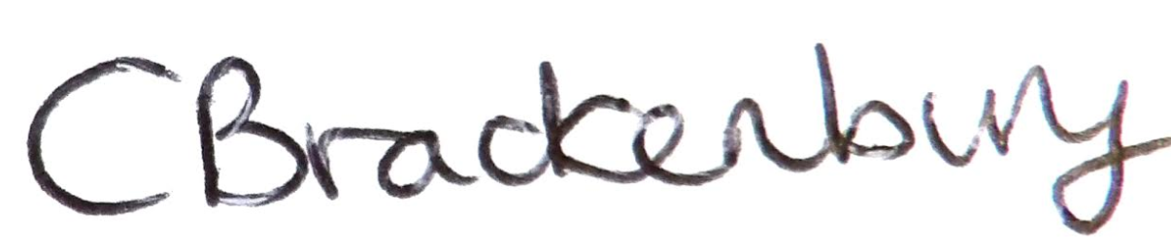
Mrs Catherine Brackenbury
Head of Academy

