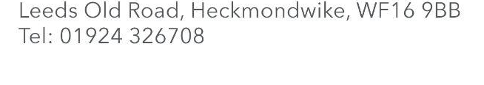

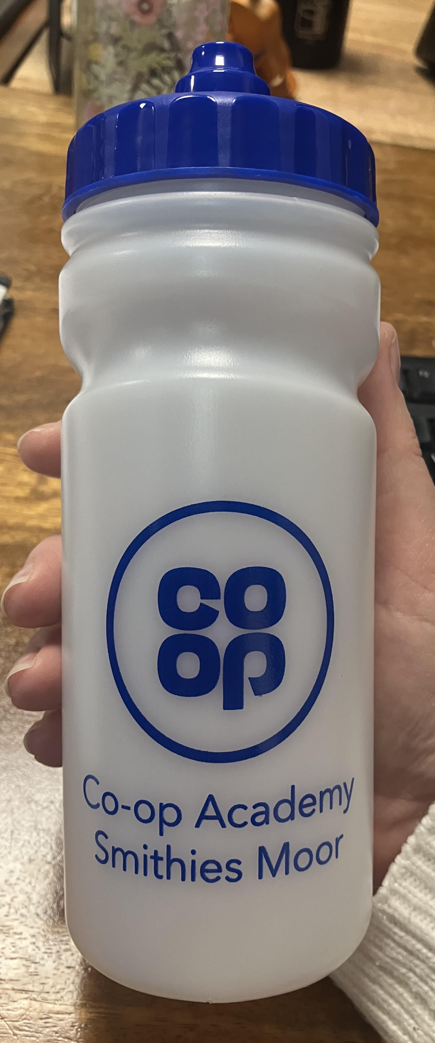
New Water Bottles

Dear Parent / Carer,

In the New Year, we are going to be more health-conscious. We are really excited to share that we have bought every child in school a new water bottle with the Smithies logo on it.

Children will be given their new bottle on Tuesday 6th January when they come back to school. They will be clean and ready for them with their name on and fresh water in.

- The new bottles will stay in school so children never need to worry about bringing one from home.
- Bottles from home that are brought in will be collected and taken to the office for you to pick up.
- The new bottles will be kept clean and sterilised and children will only ever use their own bottle.
- Children in the younger years will be supported and teachers will give out water bottles to make sure none are mixed up.

I appreciate that some children have been used to bringing their own drinks to school and this will take some getting used to, but we will support them with this. Please chat with the adults in your child’s class to share your concerns and we will help.

Best wishes,
Mrs Watkiss
Headteacher

