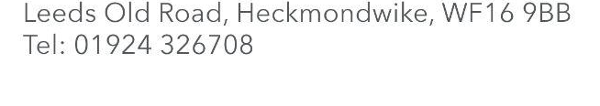

End-of-term updates

Dear Parent / Carer,

Thank you for being so warm and welcoming to Miss Sladden and I since we came to join the Smithies Moor family in mid-November. It has been a pleasure meeting some of you as you drop off your children and at the Christmas events we have had.

I wanted to share a few things that the team have been working on this term:

- We have changed our reward systems so that children can be recognised for their greatness on a daily, weekly and termly basis.
- We have introduced prizes for children and parents to reward good attendance.
- We have started to post on social media more often so you can see some of the things we’re up to day-to-day. Check out our Facebook page here: https://www.facebook.com/coopsmithies
- We have launched our new school motto: Believe Together, Achieve Together.

We want to come back to school in January and start the New Year really well. There are lots of amazing things to look forward to:

- We are going to launch new class names - look out for the big reveal in the first week back!
- We are going to be more health-conscious so we have bought every child in school a new water bottle! I will send a separate letter about this.
- We have been given £6,000 to spend on equipment for children to play with during break and lunchtimes so we welcome any ideas you might have for how to spend this.
- We are going to spend time in January, outside of school time, clearing out the building and making all the spaces more purposeful.
- We are going to invite parents into school more so we can build true partnerships for your children.

Finally, I want to wish you all a Happy Holiday and a Merry Christmas if you are celebrating.
I look forward to seeing you again in 2026!

